1. Albert is claiming that the average price of a car is 7000USD. Do you agree or disagree with Albert’s claim? Perform hypothesis testing using one-sample t-test.

* I do not agree with Albert’s claim. The average price of car is not 7000USD

**Stating of Hypothesis**

Null hypothesis: The average price of car is not 7000USD.

Alternative hypothesis: The average price of a car is 7000USD.

**Results**

At 95% confidence level, we reject the null hypothesis implying that the average price of a car is not 7000USD. This is because the p-value (0.0174) is less than the significance level 0.05.

1. Cars imported from foreign countries are perceived to be more expensive than domestic cars. Use the data provided to perform two independent sample t-test to check if there is a difference in the foreign and domestic car prices.
2. **Stating of Hypothesis**

Null Hypothesis: There is no statistically significant difference in the prices for cars between foreign and domestic.

Alternative Hypothesis: There is statistically significant difference in the car prices between foreign and domestic.

**Results**

At 95% confidence level, we fail to reject the null hypothesis implying that there is no statistically significance in prices from foreign and domestic. This is because the p-value (0.6802) is more than the significance level 0.05.

1. Plot a scatter plot for the price (y-axis) and weight (x-axis).

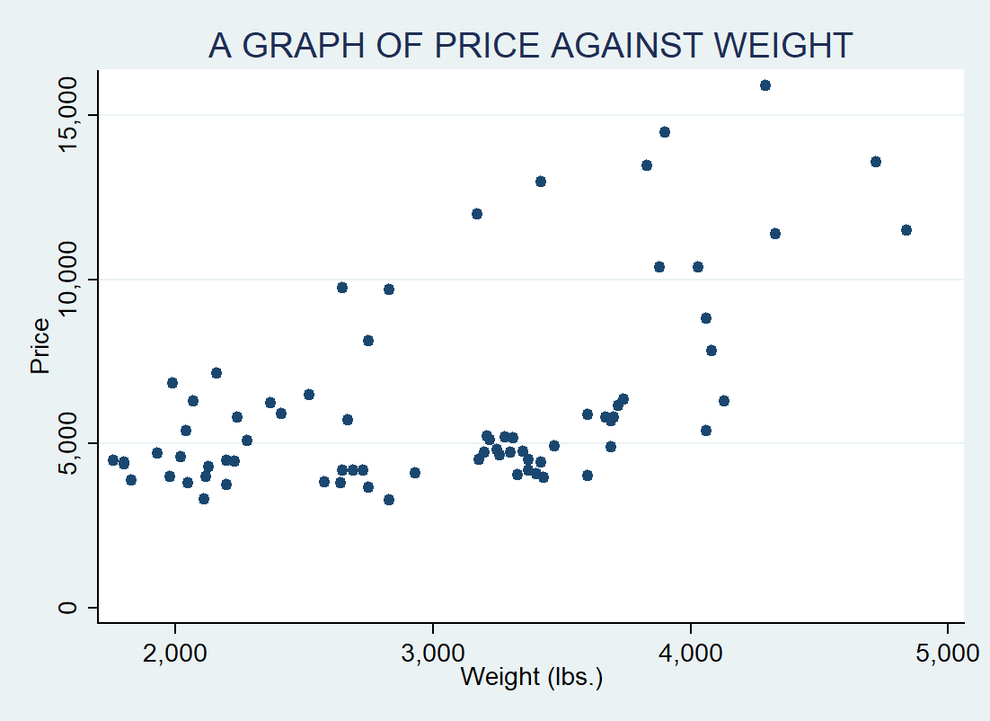

1. Perform correlation analysis on price and weight.